**Background / Context**

Nourish Research Project

[Take Home Assignment](https://drive.google.com/drive/folders/1Lpel4HPANjl9R_swkrvBrDWDeSooXPjb)

Last updated Sep 22, 2025

Nourish is a national provider of Medical Nutrition Therapy (MNT), with a network

of 4,000 licensed registered dietitians serving patients across all 50 states.

Nourish is the leading national provider of virtual Medical Nutrition Therapy

(MNT), connecting patients with registered dietitians for evidence-based,

insurance-covered care across all 50 states. We have a network of 4000 licensed

registered dietitians covering a wide range of conditions — including obesity,

diabetes, GI disorders, eating disorders, women’s health, and more. Our program

offers 1-1 virtual MNT over a series of 3-4 months, along with complimentary

access to our AI-powered mobile app with features such as on-demand

messaging with RD, AI-driven macro tracking, outcomes tracking, recipes, and

More.

Our care is focused on preventing and reversing chronic disease, and we have the

deepest experience in cardiometabolic disease. About 90% of Nourish patients

have one or more chronic condition - including 60% with diabetes, prediabetes, or

a CV condition, and 80% with obesity or overweight. 60% have 2 or more chronic

Conditions.

Our business model is based on fee-for-service contracts across major payers

such as UnitedHealthcare, Aetna, Cigna, and Regence. We accept commercial and

Medicare insurance. We are also starting to explore value-based arrangements

(i.e. pay-for-performance and case rates) and employer-sponsored partnerships.

As we grow, our ability to generate rigorous clinical evidence will be a core

differentiator — both to establish the efficacy and of our care model on clinical

outcomes and cost savings, and to shape the broader conversation around the

role of nutrition in chronic disease management.

**Research Roadmap**

Part 1: Clinical Research Roadmap

# 1a - Research Strategy & Roadmap

## Roadmap Development

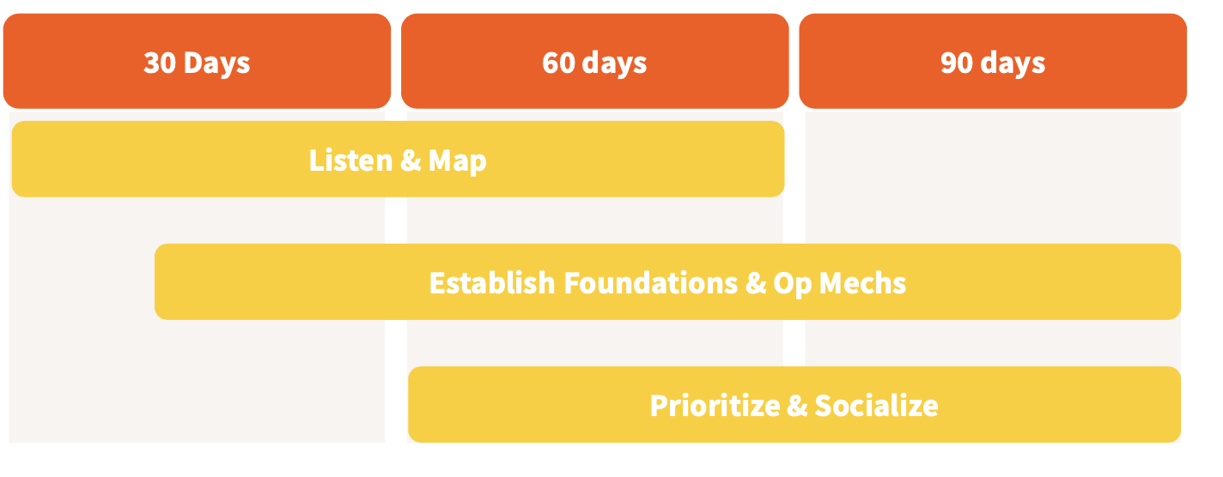

**Listen & Map**

* Engage in listening tour with key internal cross-functional stakeholders and external SMEs (e.g. existing health plan partners/advisors, friendly academic network)
* Inventory existing data sources (claims, engagement, EHR integrations, dietitian notes) and research assets (external papers, internal analyses)
* Audit relevant infrastructure (data, product, compliance, clinical ops)

**Build Foundations & Key Op Mechs**

* Draft Research team charter and other key artifacts/documentation
* Establish umbrella IRB protocol (if this doesn’t exist already)
* Build operating rhythm, project management systems, and mechanics with XFN partners (e.g. recurring meetings, Slack, and other async collaboration tools)

**Prioritize & Socialize**

* Prioritize potential projects based on impact/feasibility framework (more details below)
* Socialize plan with leadership and key cross-functional stakeholders, iterate as needed

Maybe something on outputs

## Prioritization framework

### Strategic Anchors & Inputs

* **Business impact:** Research priorities clearly mapped to *specific* company and commercial goals (e.g., payer adoption, provider trust, consumer marketing claims & credibility).
* **Feasibility:** resourcing clearly scoped to account for data availability/quality, team capacity, cross-functional and partner dependencies
* **Research team specialization:** articulation of relative focus on clinical and outcomes research vs. other related areas (product/user research, client reporting, analytics)

### Key inputs into prioritization

| **Dimension** | **Questions to Ask** | **Scoring** |
| --- | --- | --- |
| Impact | Is there a clear link to company (commercial/product) strategy and goals?  Will this directly support commercial conversations?  Does this help differentiate Nourish compared to key competitors?  Is there potential broader scientific and industry impact? | Low = minimal business impact  Medium = some relevance  High = directly relevant to most commercial conversations |
| Feasibility | Can the question be answered with existing data or is new data collection/integration required?  Is the question clinically relevant or feasible?  Are there internal resources available to conduct study & disseminate findings? | Low = no data or limited clinical relevance; significant resourcing or investment needed  Medium = some investment (e..g data collection) needed  High = data exists; |

### 

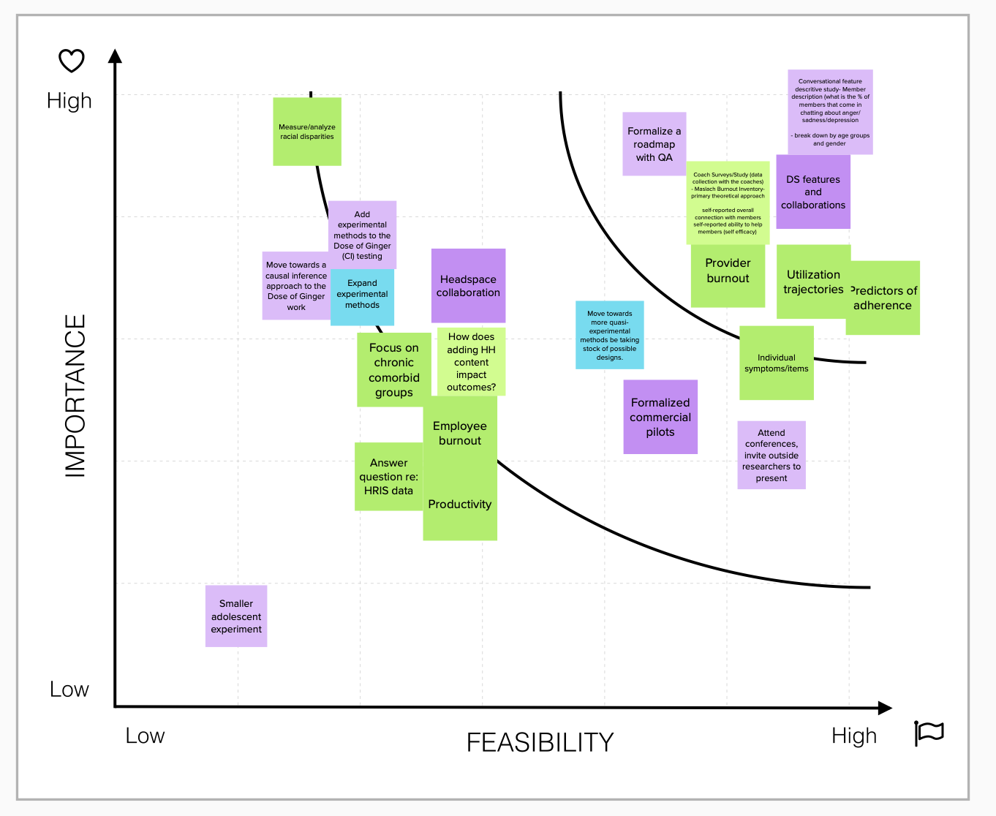

### Process, op mechs, artifacts

* **Research team charter:** summary of research vision, team, high level goals and how work supports business goals
* **AOP (annual operating plan):** develop annual roadmap that articulates research goals and deliverables in context of company strategy
* **Quarterly planning:** review progress against goals, evaluate any changes needed based on broader company changes + new requests
* **Ad hoc requests*:** evaluate bandwidth for ad hoc requests or adjustments needed to current project prioritization - ideally filtered through official project management system & request form



*\*Note: for new ad hoc requests, Research team specialization and outputs should be considered into this equation; said another way, does the request require Research SME or should it be directed to another existing function or resource if one exists. E.g. a client-specific data cut or segmentation might be better suited for client reporting teams or internal product questions redirected to core analytics teams.*

## Research outputs & deliverables

### Categories

* **Scientific output**
  + Developed by Research SMEs
  + Examples: conference abstracts/posters, internal presentations, preprints, peer-reviewed papers
* **Marketing/commercial output**
  + Translating findings to various commercial and customer-facing assets - developed collaboratively by Research & Marketing teams
  + Examples: blogs, slide decks, website collateral, white papers

### Factors to consider

* **Novelty & impact of findings:** are the findings “publishable”? Is there enough of a net new message to justify investing time & energy into the peer review process?
* **Audience**: will a scientific output (e.g. peer-reviewed paper) matter to this audience? E.g. some RFPs specifically request peer-reviewed studies, other audiences (e.g. smaller employers) might be OK with a 1-2 pager or technical paper.
* **Resourcing**: are there resources to support supplemental marketing outputs?
* **Timing**: how long will it take to get to the final output? Are there interim deliverables that can be developed?

| **Deliverable** | **Audience** | **When to prioritize** |
| --- | --- | --- |
| ***Scientific outputs*** | | |
| Abstract | Scientific community |  |
| Peer-reviewed papers | Payer clinical leadership  Scientific community |  |
| ***Marketing outputs*** | | |
| Blog | Consumers,  sales top of funnel |  |
| Slides (pitch deck etc) |  |  |
| White papers |  |  |

### Process

As part of project planning and scoping, the Research team should clearly outline intended outputs and associated timing. For. Branded templates for blogs, 1-2 pagers, and white papers can also alleviate

visual on resourcing <> credibility spectrum

### 

### Example

## Key XFN inputs & collaborators

| **Team** | **Information Needed** |
| --- | --- |
| Commercial/Sales | Wish list for sales collateral and outputs, outcomes and stats  Feedback from RFPs and sales convos |
| Marketing | Key company/product messaging segmented by audience and channels  Resourcing, R&R to collaborate on outputs and commercial enablement (e.g. blogs, decks, white papers, training) |
| Clinical (Services & Ops) | Collaborate on defining clinical relevance and endpoints  Advise on clinical protocols for study design and manuscripts |
| Data Science/Analytics | Provide info on existing analyses, metrics  Consult/collaborate on more advanced statistical methods and analyses |
| External SMEs | Validate/challenge topics and prioritization |

# 1b - Proposed Research Roadmap*

## Topic 1 - Diabetes Outcomes

* **Core question:** Does participation in Nourish’s nutrition program reduce A1C and medication dependence among adults with type 2 diabetes?
* **Business rationale**
  + Diabetes is a top cost driver for payers and has a direct ROI story.
  + There are well-defined and agreed upon clinical outcomes for this population and condition.
  + It is a highly prevalent condition among existing Nourish users compared to other high cost/prevalent conditions.
* **Data**
  + Program engagement (e.g. sessions completed, total time engaged)
  + Primary outcomes: pre/post A1C, medication use (ideally via claims integration, but probably self-report to start)
  + Potential secondary outcomes: quality of life, stress/anxiety, self-efficacy
* **Methods**
  + Descriptive analysis (mean, range) of engagement, primary and secondary outcomes
  + Pre/post tests for primary and secondary outcomes
    - Paired t-tests for continuous outcomes
    - McNemar’s test for binary outcomes (e.g. A1C<7%, medication yes/no)
  + Regression-adjusted models evaluating association between outcomes and program engagement, controlling for demographics
    - Linear mixed models (for continuous outcomes).
    - Generalized estimating equations (GEE) (for correlated binary outcomes).
* **Output(s)**
  + **Primary output:** peer-reviewed paper - this is a novel area and high priority population for Nourish to show value to payers
  + **Interim/supplemental outputs**
    - **White paper/slides:** highlight key findings after study completion
    - **Preprint:** link in marketing assets after paper submission to journal
    - **Blog:** further disseminating study findings upon publication
* **Key headlines + supporting metrics**
  + Nourish improves diabetes outcomes and associated costs
    - X% average reduction in A1C at 6 months; X% of members reduced A1C
    - X% of members reduced diabetes-related medication use
  + Nourish improves quality of life for members with diabetes
    - X% average increase in patient-reported quality of life.
    - X% of members reported improved quality of life.
* **Timeline:** 6-9 months from study design to completion/publication with interim outputs noted below**

| **Phase** | **Months** | **Milestone / Outputs** |
| --- | --- | --- |
| Study Design + Exploratory Analysis | 1-3 months | Finalized study design  Data inventory |
| Data Analysis + Manuscript Development | 1-3 months | Slides with key findings  Manuscript for journal submission |
| Peer Review + Marketing | 3-6 months | Peer-reviewed publication  Supplemental marketing collateral |

## Topic 2 - Cost Savings & Utilization Impact

* **Core question:** Does Nourish reduce healthcare utilization and costs for patients with chronic diseases?
* **Business rationale:** 
  + Directly addresses financial ROI
  + Can be used to develop/iterate on prospective models for sales
  + Ability to include multiple conditions/populations in addition to deeper segmentation (e.g. include any members with chronic conditions, but also provide results by condition grouping)
* **Data**
  + Program engagement (e.g. sessions completed, total time engaged)
  + Claims data (inpatient, outpatient, pharmacy).
    - PMPM costs (overall and by category)
    - Utilization: inpatient, outpatient, pharmacy)
* **Methods**
  + Ideally: difference-in-differences (DiD) analysis comparing spend and utilization trends for Nourish vs matched control.
  + Alternatively: concurrent benchmark analysis could be used if longitudinal data are not available
* **Output(s)**
  + **Primary**: technical paper and slides summarizing key findings; note: peer-reviewed publication could be pursued over the longer term, but typically less common for financial/actuarial analyses and audiences vs. clinical outcomes and audiences
  + **Supplemental**:
    - Payer-facing ROI model (with actuarial support)
  + **Longer term:** peer-reviewed paper
* **Key headlines + supporting metrics**
  + Nourish members see meaningful reductions in total cost of care: X% lower overall PMPM (per member per month) costs.
  + Nourish reduces medication utilization in spend: X% reduction in pharmacy spend; $X lower annual pharmacy spend
* **Timeline:** assuming there is an existing client/partner with retrospective d. If this does not exist, it will materially change the timeline: +18 months if data collection needs to start from scratch; +3-6 months

| **Phase** | **Months** | **Milestone / Outputs** |
| --- | --- | --- |
| Contracting +  Study Design | 1-6 months | Finalized study design  Data inventory |
| Data Integration + Analysis | 3-6 months | Slides with key findings  Manuscript for journal submission |
| Dissemination | 1-3 months | Slides  White/technical paper |

## Other High Priority Topics to Explore

* **Clinical outcomes for prevalent, high cost condition areas that are relevant Nourish intervention**
  + Cardiovascular health
  + GI health
  + Women’s health
  + Cancer
* **Comparative effectiveness: direct comparison of Nourish outcomes vs. standard of care or alternative solutions**

*\*In addition to looking at relative prevalence and cost of conditions as an input to prioritizing topics, I would also want direct feedback/input from commercial teams on which conditions and populations to prioritize. Said another way, while diabetes might rise to the top based on cost and market/member prevalence, there might be a reason to prioritize another area (e.g. GI health, women’s health) if there is a strategic opportunity. E.g. a payer wants to partner on nutrition support for a specific population (GI, postpartum) that’s not covered by existing offerings.*

*\*\*Timeline highly dependent on current state of data and available resourcing + journal review timelines*

# 

# 1c. Team Structure & Resourcing

High-level OKRs for the clinical research function in year 1

## Initial team structure

* **Team Lead:** Sets vision, strategy, and priorities; oversees execution, cross-functional and partner collaborations.
* **Research Analyst / Statistician:** Handles advanced analysis and ensures methodological rigor.
* **Research Generalist (e.g. Program Manager):** Flexible contributor who can support data analysis, writing, and project/program management for more complex projects and collaborations.

## Hiring plan

### Profiles

* **Generalist Builders** (early hires): Comfortable with ambiguity, can cover multiple domains.
* **Specialists** (later hires): Deep expertise in stats, HEOR, or specific therapeutic areas.
* **Translators**: People who can bridge science ↔️ business ↔️ product.

### Process & timing

* **Month 1–2:** Finalize team charter, role descriptions, budget.
* **Month 2–4:** Hire 1–2 key roles (Scientist /Analyst, Program Manager).
* **Months 6+:** Reevaluate needs based on scope and team expansion plans

## External resourcing

Any external collaborators, advisors, or academic partnerships you would want to explore

* **Consultants/contractors**: depending on scope and hiring pace, consider fractional support for more technical/advanced analysis, including actuarial and financial analytics
* **Advisors & academic partners:** 
  + Start with network of friendly (and free) academic and SME advisors
  + Within year 1, evaluate commercial need for formalizing a clinical/scientific advisory board, which requires budget + cross-functional buy-in and support (e.g. marketing)
* **Commercial partnerships:** work with commercial leads to identify areas that require collaborations with partners (e.g.

**Data + Insights**

**Appendix**

[Nourish Visuals](https://docs.google.com/presentation/d/19ZW8iS077PJPHX42YcncgnvvOrIssCum9DjjaRodb38/edit?slide=id.g38ccf726547_0_1110#slide=id.g38ccf726547_0_1110)